Amadora, Angelo John

Aquino, Kurt Neil

Choy, Matthew Seaver

**Base Query**

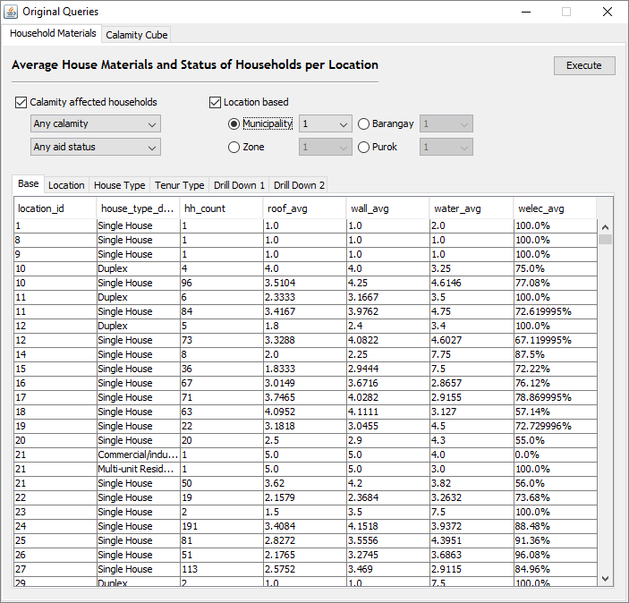

ADVANDB – S19

MCO2 Application GUI

**Rollup 1 - Location**

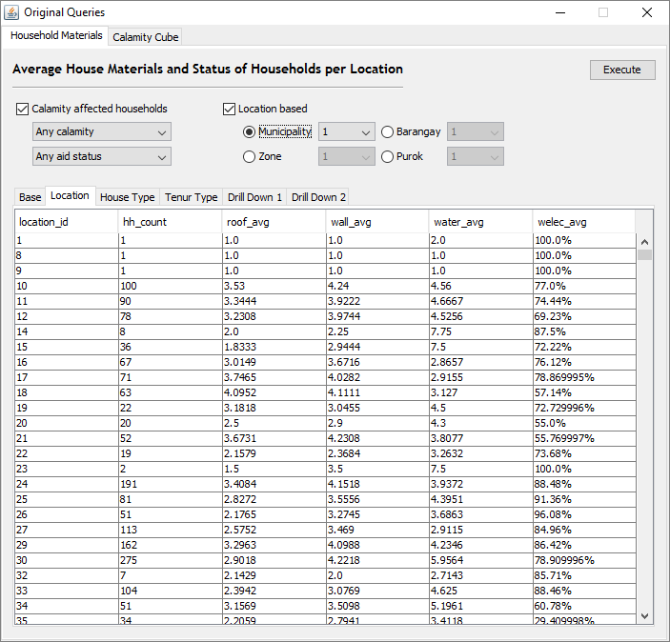

**Rollup 2 – House Type**

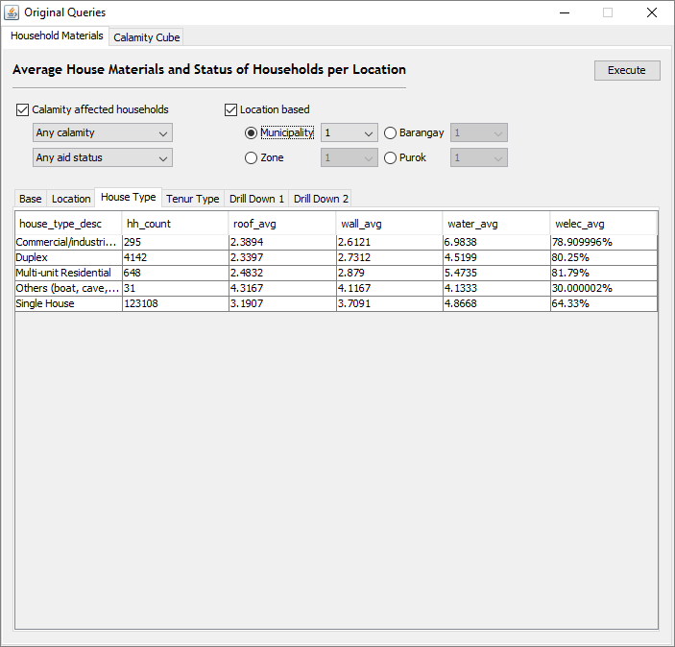

**Rollup 3 – Tenur Type**

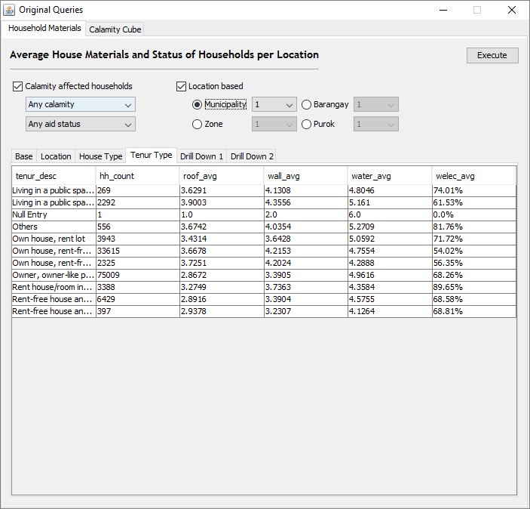

**Drill Down 1 – Location, House Type, Tenur**

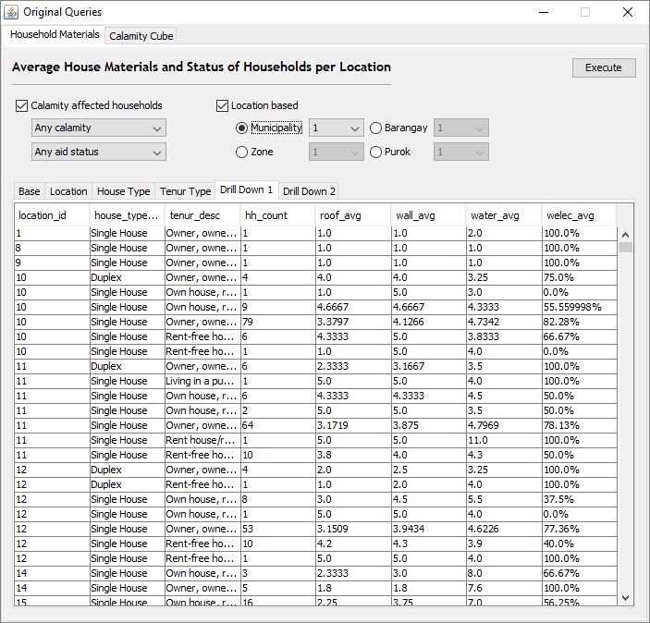

**Drill Down 2 – Location, House Type, Tenur, Household**

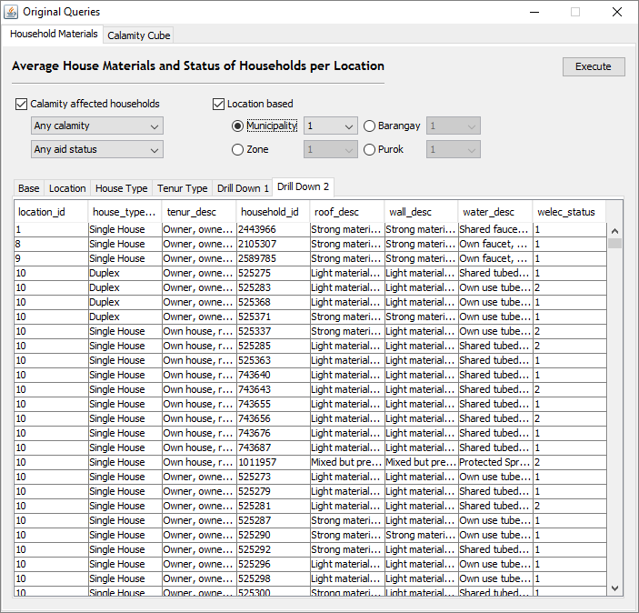

**Cube 1 – Calamity statistics per general Location**

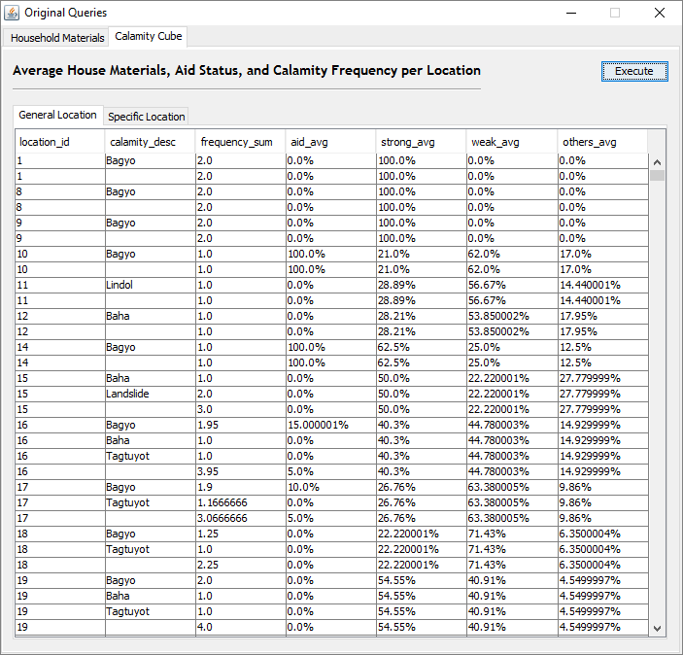

**Cube 2 – Calamity statistics per specific Location**

